University College of Southeast Norway

EXAM
4308/9004 ECOTOXICOLOGY

7.04.2017

Time: 09:00-13:00

Language: English
Pages: 4 (including front page)

Aids: Non

Remarks: Non

Appendix: Non

Exam results will be made public at the studentweb.

Task 1a. Write the full chemical names of the compounds presented below, and also the acronyms for the compounds A, C, F and H.
A) B)

C) D)
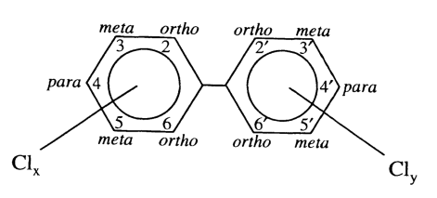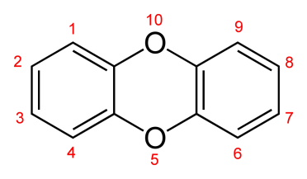
E) F)
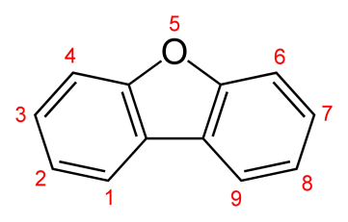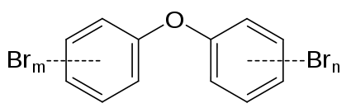
G) H)
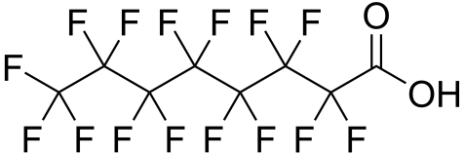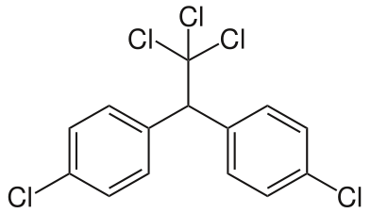
I) J)
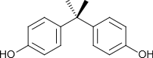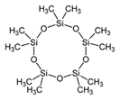

Task 1b. Explain the international term toxic equivalents (TEQ)
Task 1c. What does non-ortho PCB mean, and why do we normally incorporate them in the TEQ estimates for dioxins and furans.
Task 1d. PCB represents a group of 209 congeners. What does that mean?

Task 2a. Figure 1 (under) shows the relationship between K_{ow} (octanol-water partition coefficient) and BCF (bio-concentration factor) for different organic contaminants. Explain what BCF means and how K_{ow} is determined for different organic compounds.

Task 2b. Explain the relationship between K_{ow} and BCF in Figure 1.
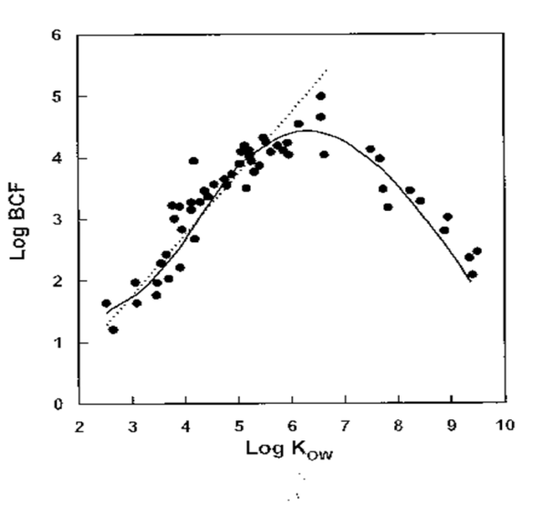
Figure 1. Relationship between Log K_{ow} and Log BCF.

Task 2c. Mention some of the most important chemical structure factors of importance for the K_{ow} partition coefficient of organic compounds, and thereby their BCF in organisms.

Task 2d. Mention the most important long range transporting mechanisms (routes) for global transport/distribution of pollutants.

Task 3a. Why is a total concentration of metal often not well correlated with toxicity, and which major physical-chemical factors in water are essential for the toxicity of metals in aquatic systems?
Task 3b. In the laboratory course, you fractionated aluminium in fresh water samples. Explain the main principles of this fractionation, and why this is important regarding biological effects on aquatic organisms?
Task 3c. Explain why we have different relation patterns between δ¹⁵N and Hg in the three fish species pike, perch and trout as shown in Fig. 2. Hint: Pike is piscivorous (fish eater) throughout the entire life.
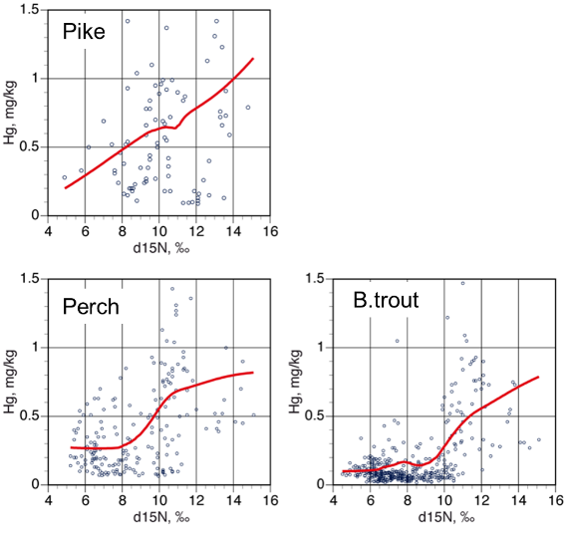
Figure 2. Relationship between δ¹⁵N and i Hg in fish from three different fish species, pike, perch and brown trout (trout).

Task 3d. In a perch population in a lake in Telemark, the following correlation were found between fish length (x-axis: in cm) and Hg concentration in fish (y-axis: in ppm):
y = 0.005x + 0.35
Estimate at which length (cm) the perch in this lake theoretically reach the Norwegian dietary advice limit of 0.5 ppm Hg.

